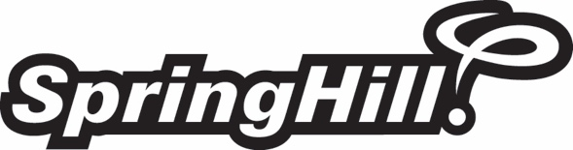

Job Description

Position Title: | Journalism + Story Gathering Intern
Established: | November 10, 2017
Classification: | Seasonal
Job Location: | Evart, MI + Seymour, IN, some travel required
Reports To: | Director of Marketing
Direct Reports: | None
Key Relationships: | Marketing, Development, Overnight operational team

Position Summary
The marketing team at SpringHill is seeking a fun, innovative, adaptable and team-oriented journalism + story gathering intern to join the team for the summer.
The Journalism + Story Gathering Intern will be responsible for gathering and capturing amazing stories in the field at one of SpringHill’s overnight properties. These stories will be used to communicate the experience to families, donors, staff and internal audiences.
The Journalism + Story Gathering Intern will be responsible for interviewing, capturing and writing stories as well as taking photos of the interviewee’s experiences. This intern will also work closely with the development team to capture stories from kids who come to a SpringHIll experience on scholarships.

Key Job Functions
- Interview kids, parents, allies and donors about their SpringHill experience
- Capture interviews and gather them in one collective database
- Write stories to be used in scholarship books, blogs, and other promotional materials
- Take photos and videos of the person and their experience
- Complete other duties as assigned by the Director of Marketing/VP of Development

Experience and Qualifications Requirements
- Commitment to the mission and ministry philosophy of SpringHill
- Open to living at an overnight camp property and traveling to day camp as needed
- Journalism, Communications, PR, Marketing Major or related
- Experience in photography and/or videography
- Experience in interviewing
- Strong communication and written skills

Working Conditions and Physical Requirements
- Must be able to lift, bend, and twist
- Ability to push and pull loads
- Must be able to lift frequently up to 35 lbs.; occasionally 35-100 lbs. with assistance
- Good hand-eye coordination

The above statements are intended to describe the general nature, types of work performed and qualifications required of staff members assigned to this position. They are not intended or should be taken as an exhaustive list of and responsibilities, duties, and requirements of personnel so classified. All indicated qualifications, duties and functions are essential job functions for purposes of the Americans with Disabilities Act (ADA).

Revised on: 11/10/2017

